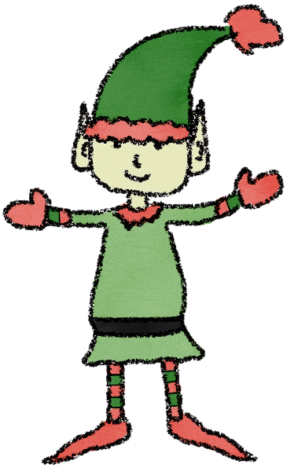
Dear Santa,

Hello! I am ……………………………….. (PUT YOUR ELF’S NAME HERE)
I want to report you about …………………….(PUT YOUR NAME HERE)
He/she is a very nice/naughty boy/girl!
This is his/her day:
He/she wakes up at ……………..(PUT THE TIME YOU USUALLY GET UP), then he/she washes her face, brushes his/her teeth, has breakfast.
She goes to school at ………………. (PUT THE TIME YOU USUALLY GO TO SCHOOL), where he/she has lunch with his/her friends and teachers.

In the afternoon, he/she does his/her homework and plays.
In the evening he/she has dinner and watches tv.
At …………… (PUT THE TIME YOU USUALLY GO TO BED) he/she goes to bed.
Good Deeds report
I want to also report about his/her good deeds.
TICK YOUR GOOD DEEDS IN DECEMBER 2020
- Do all my homework
- Help my mum and dad
- Tidy up my bedroom
- Make my bed
- Help my friends if they are in need
- Call a friend
- B nice with my brothers/sisters

Sincerely,

Elf (put the elf’s name here)

